Embed git commit hash in a .Net dll
版本信息管理前提：Project已提交至版本库（例如：GitTag_Demo项目当前版本信息：1.0.3.0-25d91eb）
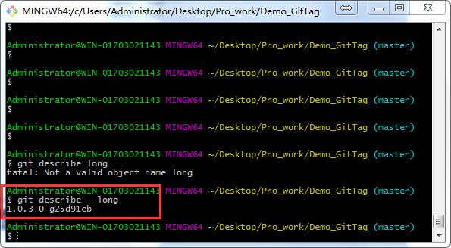
运行GitTag_Demo程序：
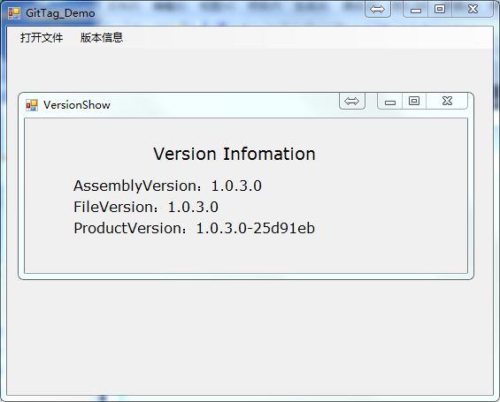
当修改源程序后，会有文件变更显示（例如：增加一行显示当前时间），产品信息列最后增加-FileModified，版本信息没有变更，文件变更提示提醒开发者进行新版本提交。
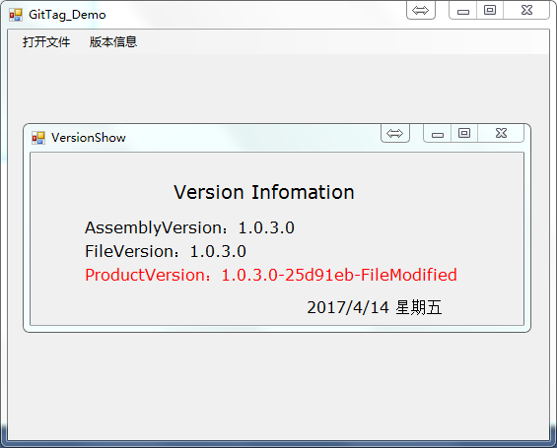
新版本提交：
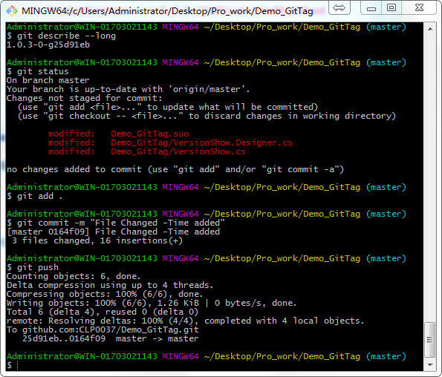

伴随着新版本提交，可以实时更新版本号：
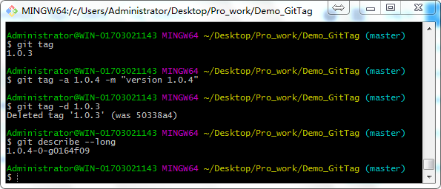

清理解决方案后，重新生成解决方案，运行GitTag_Demo程序如下，版本信息配套更新：
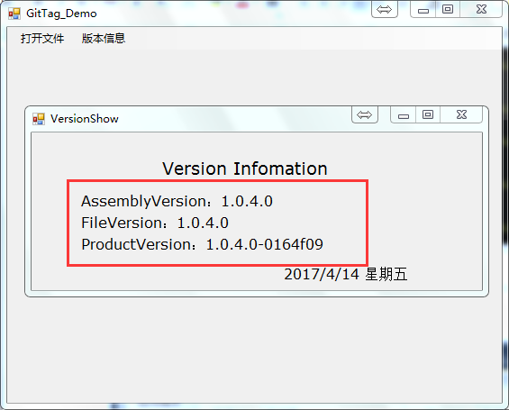

附件：
Step 1: make an AssemblyInfo_template.cs file in the Project\Properties folder, based on your original AssemblyInfo.cs but containing:
[assembly: AssemblyVersion("$FILEVERSION$")][assembly: AssemblyFileVersion("$FILEVERSION$")][assembly: AssemblyInformationalVersion("$INFOVERSION$")]

Step 2: Create a powershell script named InjectGitVersion.ps1 whose source is:
# InjectGitVersion.ps1## Set the version in the projects AssemblyInfo.cs file#
# Get version info from Git. example 1.2.3-45-g6789abc
$gitVersion = git describe --long --always;
$gitModified = git status --short -uno;
if( -not $? )
{
$msg = $Error[0].Exception.Message
"Encountered error during Deleting the Folder. Error Message is $msg. Please check." >> $LogFile
exit
}
# Parse Git version info into semantic pieces
$gitVersion -match '(.*)-(\d+)-[g](\w+)$';
$gitTag = $Matches[1];
$gitCount = $Matches[2];
$gitSHA1 = $Matches[3];
# Get file Modified info
If([String]::IsNullOrEmpty($gitModified))
{
$gitStatus ="";
}
Else
{
$gitStatus ="-FileModified";
}
# Define file variables
$assemblyFile = $args[0] + "\Properties\AssemblyInfo.cs";
$templateFile = $args[0] + "\Properties\AssemblyInfo_template.cs";
# Read template file, overwrite place holders with git version info
$newAssemblyContent = Get-Content $templateFile |
%{$_ -replace '\$FILEVERSION\$', ($gitTag + "." + $gitCount) } |
%{$_ -replace '\$INFOVERSION\$', ($gitTag + "." + $gitCount + "-" + $gitSHA1 +$gitStatus) };
# Write AssemblyInfo.cs file only if there are changesIf (-not (Test-Path $assemblyFile) -or ((Compare-Object (Get-Content $assemblyFile) $newAssemblyContent))) {
echo "Injecting Git Version Info to AssemblyInfo.cs"
$newAssemblyContent > $assemblyFile; }

Step 3: Save the InjectGitVersion.ps1 file to your solution directory in a BuildScripts folder
Step 4: Add the following line to the project's Pre-Build events
powershell -ExecutionPolicy ByPass -File $(SolutionDir)\BuildScripts\InjectGitVersion.ps1 $(ProjectDir)
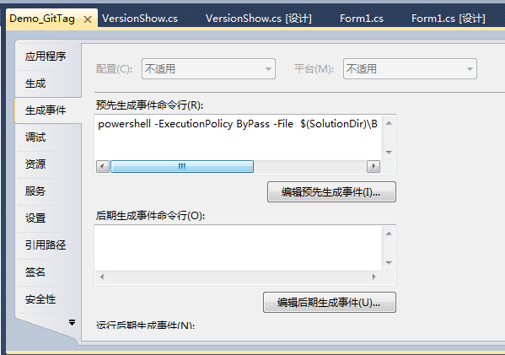
Step 5: Build your project.
Step 6: Optionally, add AssemblyInfo.cs to your git ignore file

